Commercial CO2 Sensor with MQTT Communication – Datasheet

1. Product Overview
WIN-SN-CO2-W is a versatile data acquisition device designed for real-time monitoring in industrial applications, especially ducts. It supports a wide range of external sensors with UART interface, providing flexibility for various measurements. Offering reliable communication and long-range data transfer over several meters, making it ideal for large-scale installations.
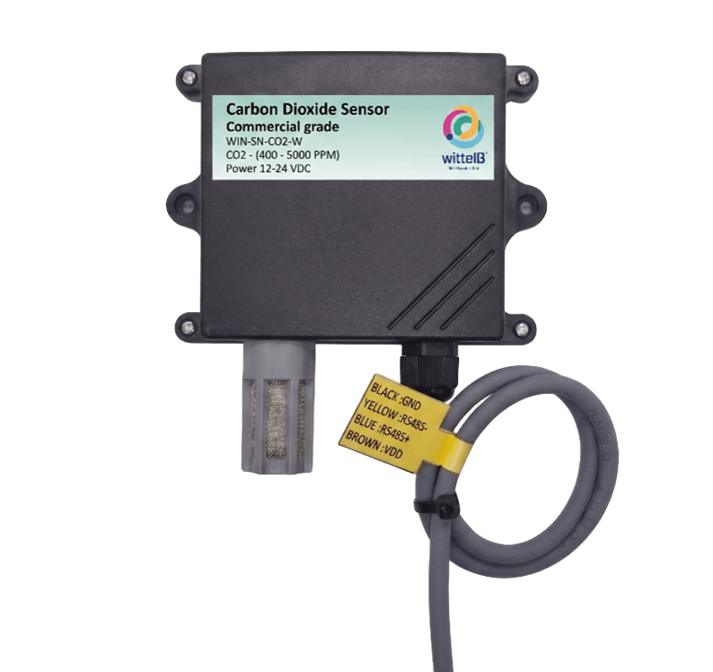
Its robust design makes it suitable for installations in HVAC systems, environmental monitoring, and process control. With configurable data sampling rates, multi-sensor compatibility, and easy configuration, WIN-SN-CO2-W ensures accurate CO2 data acquisition and reliable performance in demanding industrial environments, making it an excellent choice for industrial and IOT applications.

Fig.1 - Product Image

 | Measuring Parameter | Measuring Range | Accuracy
☐ | Carbon Dioxide Measurement Range | 400 – 2000 PPM | ±50.0 ppm ±5.0 %m.v.
☐ | Carbon Dioxide Measurement Range | 400 – 5000 PPM | ±50.0 ppm ±5.0 %m.v.
Table 1

2. Sensor Specifications
- Wide temperature range: −40 °C to +125 °C
- Full humidity range: 0 % to 100 % RH
- Power supply DC: 12-24V@1A.
- Product dimension: 85*85*36 mm.

- Certifications:

3. Power Supply Connection
DC Connection
- Use 12-24V@ 1A, Power supply.
- Don’t make loose connection.

4. Recommended Cable Electrical Characteristics
22 AWG Cable Shielded and twisted pair should be used.
Tinned Copper Recommended
Nominal Conductor DCR 14.7 ohm / 1000 ft
Nominal Capacitance 11 pf / feet (conductor to conductor)
High Frequency Non-Insertion Loss 0.5db / 100ft

5. Device Configuration Process
- Connect the Device
  - Connect 12v-1A DC adaptor to power the board
  - Connect the Wi-Fi SSID: WittelB-SN-CO2 Pass:123456789
  - Enter the IP 192.168.4.1 in web browser
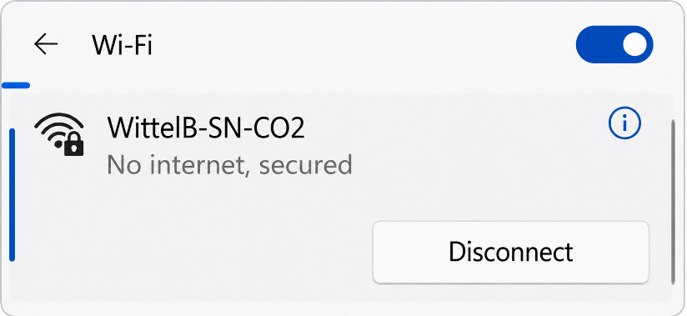
  - Refer image 1 for Wi-Fi WittelB-SN-CO2

Image: 1
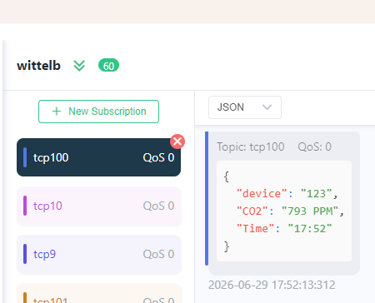
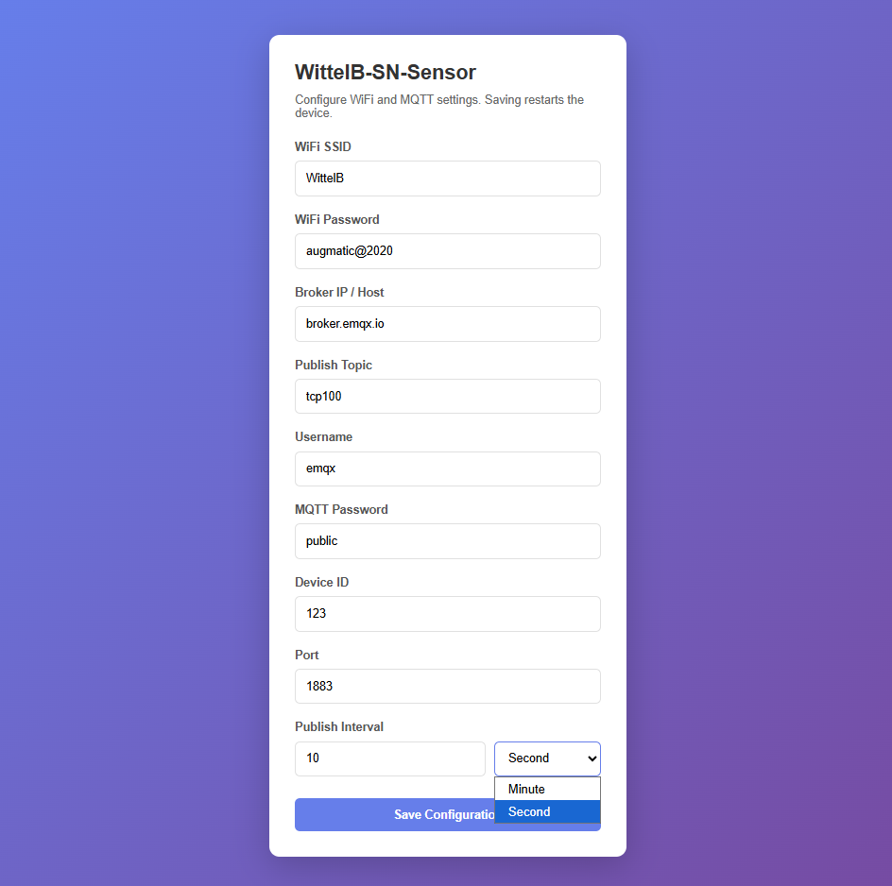

Image: 2 Image: 3
- Enter IP 192.168.4.1 in web browser then you will see the Web UI.
- Enter the local WiFi credentials as shown in above image2 so the device can connect to that WiFi network. Using this connection, it will send the sensor data to the cloud.
- Then enter the required MQTT Credentials and make sure the credentials should be correct.
- As shown in Image 2, you can select the publish interval in either minutes or seconds. MQTT data will be published according to the selected interval.
- Enter the MQTT credentials to transmit the sensor data to the cloud.
- Image 3 shows the sensor data at cloud for the selected topic.
- The published JSON payload includes a real-time timestamp, allowing each sensor reading to be tracked with its exact time.

Contact Information
Augmatic Technologies Pvt. Ltd.,
Plot no 6, Shah Industrial Estate II,
Kotambi,
Vadodara – 391510.
Email – Sales@wittelb.com
Support: support@wittelb.raiseaticket.com / +91 94038 92805

